Identifying Data Quality Issues & Data Cleaning
As the data set is small, rectifying data quality issues is prioritized rather than dropping rows entirely for most cases.

Issue 01- Redundant Exact Duplicate Customer Records
Observation: Running data.duplicated() identified 3 exact duplicate rows appended at the end of the dataset (index positions 500, 501, and 505). These rows match earlier records (indices 10, 45, and 280) identically across all 44 attributes.
Remediation Strategy: Deduplicate the dataset by dropping all exact duplicate rows while retaining the first occurrence.

Issue 02- Duplicated Customer_ID and NICs
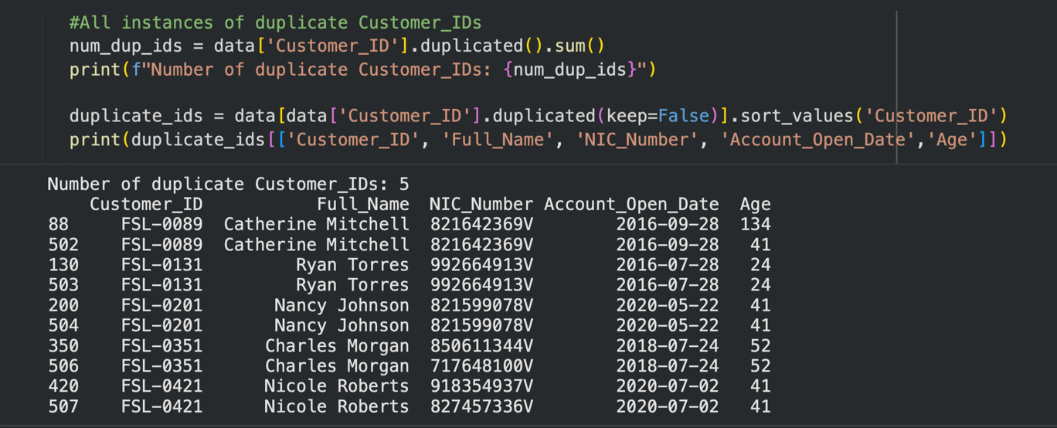
Fixing rows that can be verified:
FSL-0089 (Catherine Mitchell): Row 88 lists DOB as 1890-03-11 (Age 134), whereas Row 502 lists 1982-06-13 (Age 41). Kept Row 502 because Row 88 is physically impossible.
FSL-0131 (Ryan Torres): Row 130 has KYC_Status = NaN, whereas Row 503 has KYC_Status = 'Pending'. Kept Row 503 to preserve metadata.
FSL-0201 (Nancy Johnson): Row 200 lists Last_Login_Date = 2025-08-20, whereas Row 504 lists 2023-10-10. Kept Row 200 as it contains the newer activity.
Fixing rows that cannot be verified:
FSL-0351 & FSL-0421: Has conflicting NICs. The record seem to be belonging to same individuals as the rest of the records are identical. KYC is also verified for both NICs, hence, the entry seems to be an error. There is no way to deduce the exact NIC of the rows, hence NIC set to NaN and the extra one dropped as rest of the record is similar.
FSL-0076 & FSL-0461: Has same Ids but the records seem to be belonging to different customers. Records seem to be genuine and the NIC is more likely to be a data entry error. Hence NIC set to NaN and both records kept but flagged for authentication.

Issue 03- Inconsistent Formatting
Observation:
Categorical inspection revealed formatting and entry inconsistencies across three text fields: Gender contains eight variations including full words, single-character codes, and mixed casing ('Female', 'Male', 'M', 'male', 'FEMALE', 'F', 'MALE', 'f'); District includes clerical spelling typos ('Columbo', 'Kanady', 'Gale', 'Jafna'); and Account_Status exhibits non-standard casing ('active', 'INACTIVE', 'suspended') alongside trailing whitespace ('Active ')
Remedy:
Apply dictionary mapping (gender_mapping) to unify all Gender variants into 'Female' or 'Male', replace District typos with correct Sri Lankan district names via .replace(), and clean Account_Status values by stripping trailing whitespace and applying title-casing via .str.strip().str.title().

Issue 04- Age Field Discrepancies
Observation:
Logical cross-validation between Date_of_Birth and Age revealed critical discrepancies and data entry corruption across the dataset. The existing Age values contained both minor rounding/off-by-one errors and severe impossible outliers (e.g., agesrecorded as 99 and 150).
Remedy:
Date_of_Birth was established as the reliable source of truth. Replaced the 19 mismatched Age entries with Calculated_Age using boolean mask indexing (data.loc[mismatch_mask, 'Age'] = calculated_age[mismatch_mask]).

Issue 05- Net Monthly Flow Computation Discrepancy
Observation:
Cross-column mathematical verification revealed two severely corrupted records (FSL-0126 and FSL-0296) where the recorded Net_Monthly_Flow values (3473.72 and 1488.34) did not equal the arithmetic difference between Monthly_Deposit_Avg and Monthly_Withdrawal_Avg (-9990793.36 and -8880753.76).
Remedy:
Net_Monthly_Flow is definitely the ground truth column here, while Monthly_Withdrawal_Avg is corrupted with dummy/sentinel placeholder values. These non-random repeating digit numbers (9.99 million and 8.88 million) are classic database system placeholders for missing or system-errored numeric entries. Since Net_Monthly_Flow and Monthly_Deposit_Avg were verified as accurate ground-truth figures, we calculated the true average monthly withdrawal for both records using the formula

Issue 06- contradictions across Loan columns
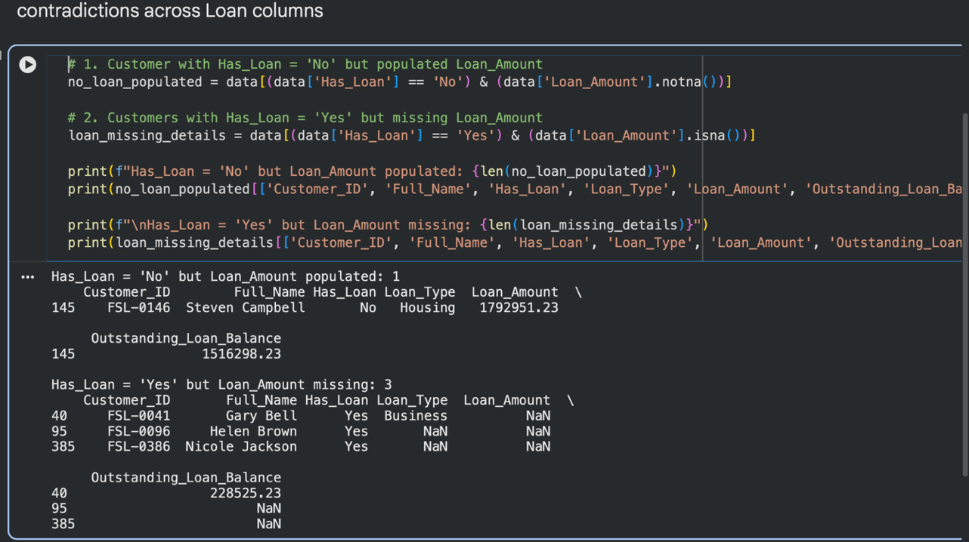
Observation
Cross-column analysis revealed four loan status contradictions: FSL-0146 had full loan details despite Has_Loan = 'No'; FSL-0041 had Has_Loan = 'Yes' and an active balance but a missing Loan_Amount; and FSL-0096 and FSL-0386 had Has_Loan = 'Yes' but completely missing loan attributes.
Remedy
Set FSL-0146 to Has_Loan = 'Yes'; set FSL-0096 and FSL-0386 to Has_Loan = 'No'; impute FSL-0041's missing Loan_Amount using the median business loan value; and recalculate Number_of_Products across all records to sync with the updated product flags.

Issue 07- Product Holding Count Mismatch
Observation
Cross-column logical validation identified 6 records where the aggregate Number_of_Products count contradicted the actual sum of active product boolean flags (Has_Loan, Has_Fixed_Deposit, Has_Insurance, Has_Mobile_Wallet).
Remedy
Programmatically recalculate Number_of_Products by evaluating the true count of 'Yes' flags across all four product indicators for every customer record.

Issue 08- Missing Values
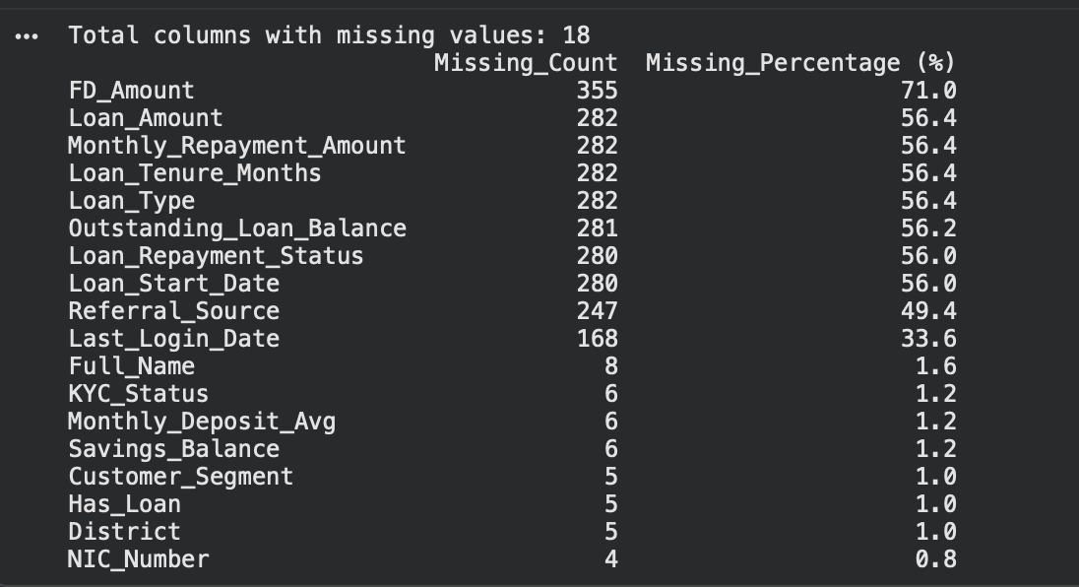

Issue 8.1- Fixed Deposit (FD) Missingness Analysis
The FD_Amount column initially shows 355 missing values (71.0%). Logical cross-validation against the Has_Fixed_Deposit boolean flag confirms that 0 records have Has_Fixed_Deposit == 'Yes' while missing an FD_Amount. All 355 NaN entries in FD_Amount correspond strictly to non-FD account holders (Has_Fixed_Deposit == 'No') where no active deposit exists. No data corruption or missingness errors exist in FD_Amount

Issue 8.2- Loan Column Missingness
Observation
Unlike Fixed Deposits, the loan-related columns (Loan_Amount, Loan_Type, Monthly_Repayment_Amount, Loan_Tenure_Months, Outstanding_Loan_Balance, Loan_Repayment_Status, Loan_Start_Date) exhibited mismatched missingness percentages (56.4%, 56.2%, and 56.0%).
A detailed audit revealed that while all active loan holders (Has_Loan == 'Yes') had complete data, the discrepancies stemmed from 9 problematic records in the non-loan and unflagged rows:
Unflagged Active Loan (1 Record): FSL-0476 (Mary Torres): Has_Loan was NaN, despite having complete active loan details (Loan_Amount = 2,897,173.84, Vehicle, Delayed, etc.). Remedy: Updated FSL-0476 (Mary Torres) to Has_Loan = 'Yes'
Unflagged Non-Loan Holders (4 Records): FSL-0086, FSL-0166, FSL-0226, FSL-0356: Has_Loan was NaN with all loan fields empty (NaN).
Stray Data Noise in Non-Loan Holders (4 Records): FSL-0049 (Kevin Cook) & FSL-0391 (Robert Wilson): Has_Loan = 'No', but contained stray Loan_Start_Date entries. FSL-0071 (Patricia Wilson): Has_Loan = 'No', but contained stray Outstanding_Loan_Balance (150,000.0) and Loan_Repayment_Status (Defaulted). FSL-0431 (Dorothy Bell): Has_Loan = 'No', but contained a stray Loan_Repayment_Status (Delayed). Cleared stray leftover values for all customers where Has_Loan == 'No' and filled the remaining 4 missing Has_Loan flags with 'No'.

Issue 8.3- Last_Login_Date Missingness Analysis
The Last_Login_Date column initially shows 168 missing values (33.06%). Logical cross-validation against the Mobile_App_User boolean flag confirms that 0 records have Mobile_App_User== 'Yes' while missing an Last_Login_Date. All 168 NaN entries in Last_Login_Date correspond strictly to non-mobile app users (Mobile_App_User == 'No'). No data corruption or missingness errors exist in Last_Login_Date.

Issue 8.4- Last_Login_Date Missingness Analysis
No issues found in Checking for NIC format validity- checked using pattern matching, Age Calculation errors- age has been calculated accurately from DOB

Issue 8.5- KYC_Status Missingness Analysis
Only 6 of the KYC_status seems to be missing. They are replaced with “pending” which is the safest option.

Issue 8.6- Monthly_Deposit_Avg Missingness Analysis
6 customer records contain missing values in the Monthly_Deposit_Avg column. However, the corresponding Net_Monthly_Flow and Monthly_Withdrawal_Avg fields may contain sufficient information to derive the missing deposit values. Identified records with missing Monthly_Deposit_Avg values and derived the missing values using the following relationship:
Monthly_Deposit_Avg = Net_Monthly_Flow + Monthly_Withdrawal_Avg

Issue 8.7- Monthly_Deposit_Avg Missingness Analysis
Several customer records contain missing values in the Savings_Balance column across different customer segments. These missing values may affect segment-level financial analysis, summary statistics, and dashboard reporting.
Imputed missing Savings_Balance values using the median savings balance within each Customer_Segment. The median was selected instead of the mean because it is less sensitive to extreme values and may better represent a typical customer within a segment.

Issue 8.8- District Missingness Analysis
Several customer records contain missing values in the District column. However, the corresponding Province information is available and may help identify a plausible district for the affected records.
Imputed missing District values using the mode (most frequently occurring district) within each Province. This approach assumes that the most common district recorded for customers in the same province provides a reasonable estimate for missing entries.

Issue 8.9- Missing Customer_Segment and Savings_Balance Analysis
Observation:
Some customer records had missing values in both Customer_Segment and Savings_Balance, affecting customer segmentation and savings analysis.
Remedy:
Missing customer segments were imputed using the most common segment among the five customers with the closest savings balances. Where both fields were missing, the segment was assigned as 'Regular'. Missing savings balances were then imputed using the median balance within the corresponding customer segment.

Issue 8.10- Final Handling of Missing Values
After investigating and resolving missing values wherever possible, the following strategies were applied to prepare the dataset for Power BI.
1. Numeric Financial Fields
Observation: Missing values remained in financial columns, including FD_Amount, Loan_Amount, Monthly_Repayment_Amount, Outstanding_Loan_Balance, and Loan_Tenure_Months.
Remedy: Kept as nan as the resulting NaN/blanls are truly not applicable values. They’re not actually zero but have no value. PowerBI DAX is capable of ignoring NaNs specially when calculating AVERAGE() and such. Also, since the presence or absence of these specific accounts is flagged as a new column in the original data set, this would be handled accordingly in power BI.
2. Categorical Loan Fields
Observation: Customers without loans had missing values in Loan_Type and Loan_Repayment_Status.
Remedy: Replaced these missing values with 'No Loan' to distinguish non-loan holders from customers with recorded loan categories and improve dashboard readability.
3. Date Fields
Observation: Missing values remained in Loan_Start_Date and Last_Login_Date.
Remedy: Converted both columns to datetime format while preserving invalid or missing dates as NaT. This maintains date compatibility for Power BI relationships, date hierarchies, and time-based analysis.
4. Referral Source
Observation: Some customer records had missing values in Referral_Source.
Remedy: Replaced missing values with 'Not Available' to make missing referral information explicit in dashboard visuals and slicers, without assuming that these customers were acquired organically.

Issue 09- Outlier/ Abnormal values

Issue 9.1 Underage Primary Account Holder (FSL-0034 / Susan Jones)
Issue: The customer record contained an Age of 3 (Date_of_Birth: 2020-05-01), violating banking compliance standards requiring primary savings account holders to be at least 18 years old.
Justification: Imputing her age to the adult customer median (38 years) restores demographic validity for segmentation and compliance analytics without dropping the customer's legitimate transaction history.

Issue 9.2 Corrupted Value in Savings_Balance (FSL-0056 / Ronald Wilson)
Issue: The record listed a Savings_Balance of 999,999,999.0 LKR, which is a system-generated placeholder value rather than a genuine balance.
Justification: Replacing this extreme outlier with the median balance of his corresponding Regular customer segment prevents severe skewing of summary statistics (mean, variance) and ensures DAX aggregations reflect actual portfolio performance.

Issue 9.3 Negative Savings_Balance Entries (FSL-0023, FSL-0100, FSL-0176, FSL-0321)
Issue: Four savings accounts displayed negative balance amounts (ranging from -5,000 to -88,000 LKR) despite being standard savings accounts without active overdraft flags.
Justification: Seems like placeholders, hence converted to nan and imputed using median of segment and tier together,

Money related data columns seem to skewed which is the expected outcome.
Issue 10- Temporal Data Anomalies and Resolutions
Issue 10.1 - Future Last Login Dates
Three records (FSL-0081, FSL-0201, FSL-0441) contained login timestamps dated past the snapshot threshold, reaching up to 2027. To preserve valid customer profile data without dropping entire rows, these invalid dates were converted to NaT. This fix retains non-temporal variables for analysis, though recency metrics like "days since last login" will produce missing values for these accounts.
Issue 10.2 - Future Account Opening Dates
Two records (FSL-0136 and FSL-0416) recorded account opening dates past the snapshot date, creating negative customer tenures. Because Customer_Tenure_Years remained internally valid, the open dates were recalculated by subtracting the tenure duration from the snapshot date (2024-01-01). This completely restored chronological accuracy and retained all customer data without introducing missing values.
Issue 10.3 - Open Date and Tenure Discrepancies
For records where calculated tenure conflicted with the recorded Customer_Tenure_Years by more than 0.2 years, the mismatched Account_Open_Date values were set to NaT. Converting these corrupted values to missing entries eliminates contradictory historical data while preserving the rest of the customer's active status and loan information. Any future vintage or cohort analysis must account for missing account open dates on these rows.
Issue 10.4 - Anachronistic Loan Origination Date
Record FSL-0116 showed a loan start date of 2012-06-15, which predated both the earliest account creation in the system and the customer's own open date. The Loan_Start_Date was converted to NaT specifically for this record, leaving the valid financial fields (loan amount, balance, and repayment status) intact for analysis. The only downside is that loan-duration features cannot be calculated for this individual loan.

